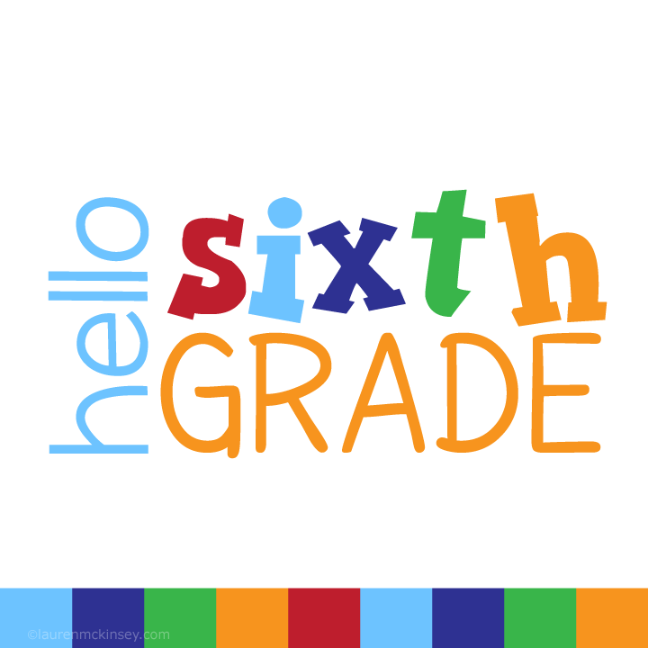

Dear Parents, Guardians, & Students,

It is with great pleasure that I would like to welcome you to the Museum 25 sixth grade! I am looking forward to an exciting and successful academic school year! I am excited to start working with all of you. Being a sixth grader is a big responsibility! Sixth graders are the biggest role models for the younger students. Expectations are high in as I am preparing all of you for middle school. The key to our success is being responsible, respectful, and safe.

In my experience it is paramount that parents and teacher work as a team and have accessible communication. Therefore, I invite all of you to e-mail me at [mraczy@yonkerspublicschools.org](mailto:mraczy@yonkerspublicschools.org) as this is one method of communication. I will also be using Class Dojo please refer to the attached invitation with the class code. Class Dojo will allow you to see your child’s progress throughout the school day and is another method of communication for us. This year we will be using Clever as our online portal, student badges are attached. We will also be using Microsoft Teams in order to instruct virtually. Students are expected to attend and complete assignments with fidelity. The instructional school day is 8:40-3:15. Assignments that are missed will filed in Microsoft Teams.

As we dive into the 2020-2021 school year students will be expected to challenge themselves daily. They are also expected to adhere to student behavior expectations when participating remotely. Students will be expected to practice individualized skills at home. Each child will be provided with their own e-mail in order to familiarize them with technology. Their e-mail is their [id@yonkerspublicschools.org](mailto:id@yonkerspublicschools.org) their password is their id number twice . They may then change it . Please write down the new password. Please know that I am here to support you as we enter this unfamiliar school year **together**. “If you can’t fly then run, if you can’t run then walk, if you can’t walk then crawl, but whatever you do you have to keep moving forward.” Martin Luther King Jr.

I am looking forward to working with all of you this school year!

Your teacher,

Ms. Raczy